Part 1
- Put these astronomical objects in order of size from largest to smallest. (3)
Fill in the boxes in the correct order.
the Moon the Sun planets asteroids

largest | the Sun | planets | the Moon | asteroids | smallest

- Complete the sentences below.
There are billions of galaxies, each containing billions of Stars.
All of these galaxies make up the Universe .
Our Sun is part of a galaxy called the Milky Way (5)
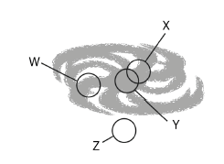
- (a) Which letter shows the approximate position of our
solar system in the galaxy? (1)
W
(b) What is the name given to planets which orbit
stars other than our Sun? (1)
Exoplanets
(c) The age of our solar system is approximately: (1)
(tick the correct box).

4.5 billion years 45 million years

4.5 trillion years 450 thousand years

Part 2
- The Big Bang theory is the currently accepted theory for how the Universe began.
- Describe how the Universe began according to the Big Bang theory. (2)

The Universe started as a single, tiny, hot, dense point.

This exploded (expanded) into the Universe we know today.

- Name one piece of evidence that supports the Big Bang theory. (1)

Red shift CMBR

- Observations of red shift of the supernova in distant galaxies suggest the galaxies at the extreme of our Universe are accelerating.

Choose the correct word to complete the above sentence. (1)

accelerating cooling down getting bigger slowing down

- Only around 5% of the known Universe is made of visible matter. What two properties are thought to make up the other 95% of the universe? (2)

Dark matter and dark energy

- Scientists have discovered over 3000 planets orbiting stars outside our solar system. Explain why probes have not been sent to see whether life exists on any of these planets? (2)
They are too far away.
It would take thousands of years for a probe to reach them.
- The table shows the distances to three different galaxies, X, Y, and Z and the speed with which these galaxies are moving.
Galaxy | X | Y | Z
Distance (millions of light years) | 400 | 900 | 2200
Speed (km/s) | 7000 | 20 000 | 50 000

Describe the correlation shown by the data. (2)
As the speed of the galaxy increases,
Its distance also increases. Faster moving galaxies are further away (2)

- (a) Light from distant galaxies is red shifted. What does this tell us? (1)
The galaxies are moving away from the Earth at high speed.

(b) Light from some galaxies show a greater red shift. What does this tell us? (2)
They are moving away at higher speed they must be further away.
(c) Circle the correct answer.

Red shift gives us evidence that the Universe is slowing down / expanding / getting hotter (1)

- The spectra below are from Star X. Underneath each Star X spectrum is the spectrum from a different element.
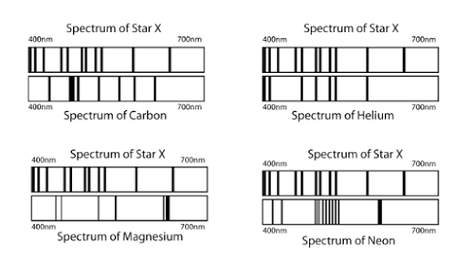

Which of the four elements is present in star X? (1)

Helium as it is the only one with a matching spectra.

- If a galaxy was moving towards the Earth, explain what the observed spectrum would look like. (3)

Light from the galaxy would have its wavelengths reduced.

Waves would appear to move towards the blue end of the spectrum.

Galaxy would exhibit blue shift.

- The spectra below show light from two galaxies when viewed from Earth.

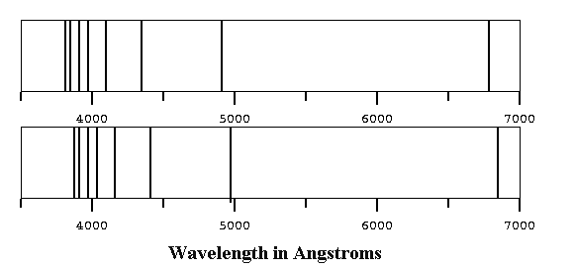
Near Galaxy

Distant Galaxy

Explain why the spectrum from the near galaxy looks different to that from the distant galaxy. (6)

Spectral lines show light is red shifted more by the distant galaxy

Red shift is caused by galaxies moving away from Earth

Distant galaxy shows greater red-shift so it is moving away,

with greater speed than near galaxy

This means galaxy is further away than near galaxy
Suggests Universe is expanding

- A star begins its life cycle as a nebula. Explain the structure of a nebula and the processes it goes through to become a star. (4)

A nebula is a dense cloud of dust and gas.

Gravity slowly pulls the dust and gas towards a central point.

As the material spirals towards the centre the mass becomes denser and begins to rotate.

When the pressure and temperature are sufficiently high, fusion begins and a star is created.


- The diagram shows the forces acting on a main sequence star.

- What do the two different arrows represent? (2)

White arrows represent thermal expansion

Black arrows represent gravitational attraction

- What can you assume about these two forces in the main sequence star? (1)

They are equal in size but opposite in direction, or they are in equilibrium

- The diagram below shows nuclear fusion in a star.
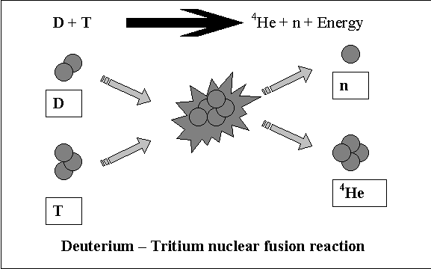

- What do the letters represent on the diagram? (3)

D = Deuterium T = Tritium

N = neutron

- What else will be given off in this reaction? (1)

Energy

- The life cycle of a massive star is shown below.
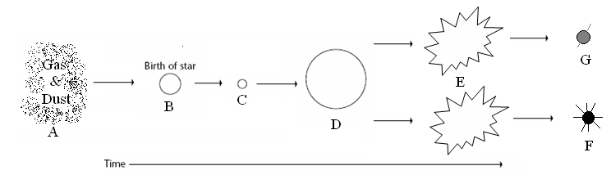

Complete the stages of the life cycle shown by the letters A to G. (4)

A Nebula B Protostar C Main sequence star

D Red super giant E Supernova F Black hole

G Neutron star (-1 mark / incorrect answer)

16. The sun is in its main sequence stage. What will happen to the sun as the hydrogen begins to run out? (2)

It will heat up and expand to become a red giant.

17. Explain why small stars remain in their main sequence stage much longer than very big stars. (2)

Small stars fuse their hydrogen (fuel) much more slowly

So, their fuel lasts much longer than with big stars which burn their fuel quickly.

18. The diagram below shows how larger elements could be made in a star. In the space below write a
reaction to show the process described. (3)
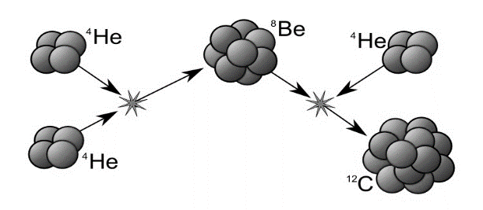

- (1) (1)
₂⁴He ⁸Be + ⁴He ¹²C

19. Elements bigger than iron cannot be produced in fusion reactions in stars.
Explain how the larger elements are created and dispersed in the Universe. (3)

Bigger elements are produced in a violent explosion by a supernova.

Where the temperatures and pressures are much greater than those found in a large star.

The explosion that produced the larger elements also disperses them throughout the Universe.

